**Lab 3 Assignment**

**To Install and configure VMware Workstation Pro or Oracle Virtual Box for creating Virtual Machines, cloning, and deleting VMs.**



1. **Cloning of Virtual Machines:**
2. **Linked Cloning**

* Right Click on VM and select clone

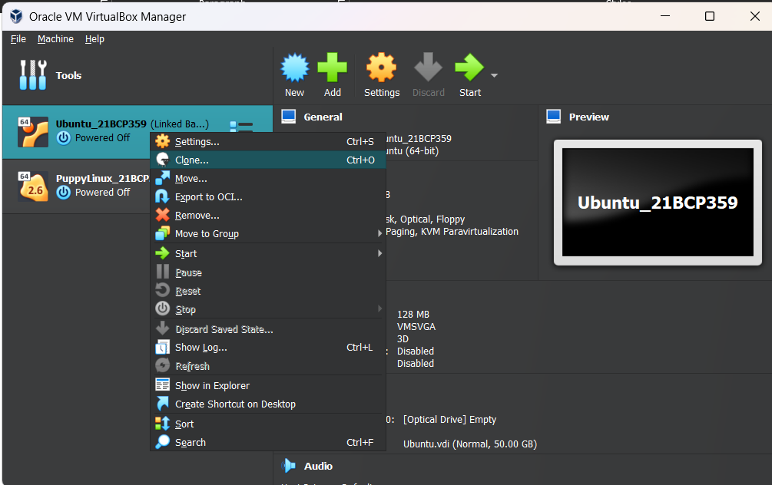

* Give necessary details

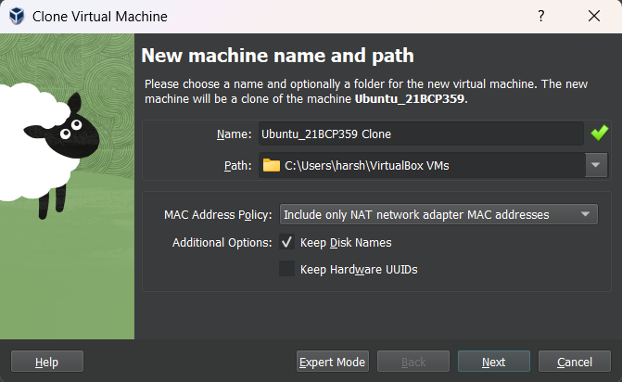

* Select Linked Clone

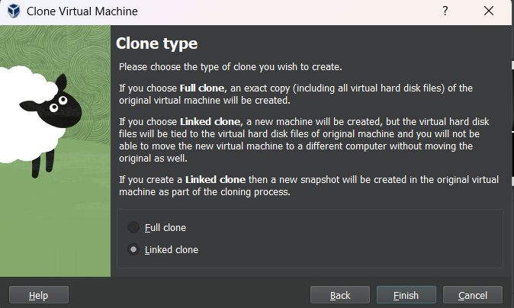

* The Linked Clone is Ready

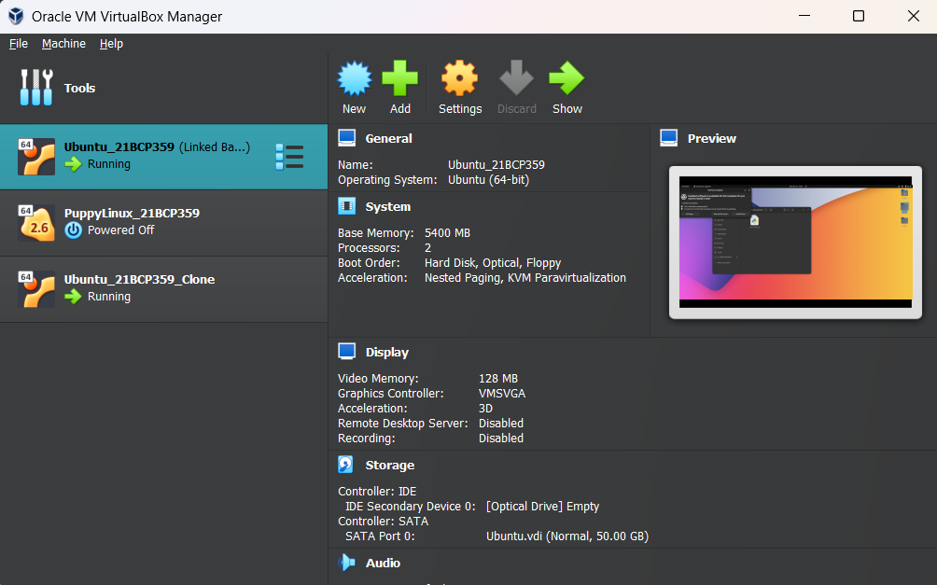

1. Full Cloning

* Right Click on VM and select Clone



* Give Necessary details



* Select Full Clone

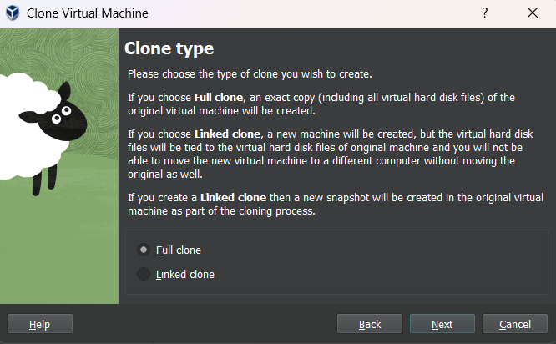

* Snapshots: Select Current Machine State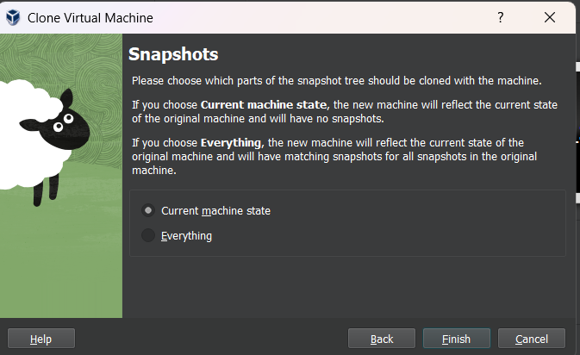

1. **Add a USB Controller to Virtual Machine**

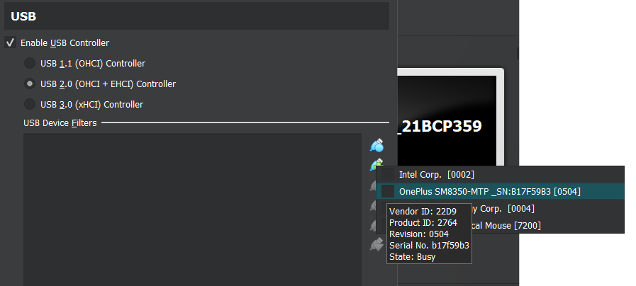

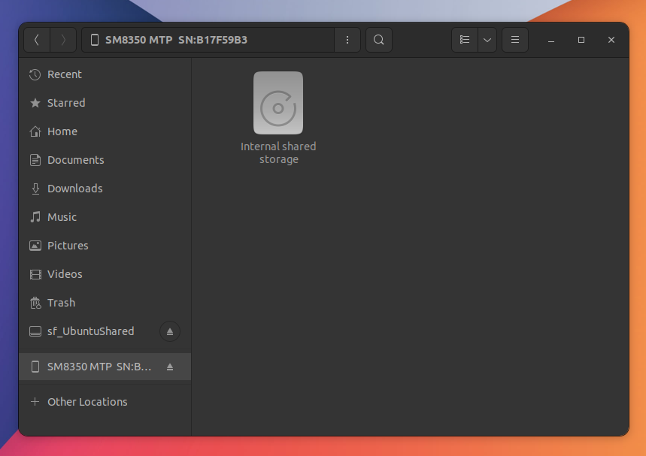

1. **Closing Virtual Machines & Exiting VMM**
   1. Hard Power Off

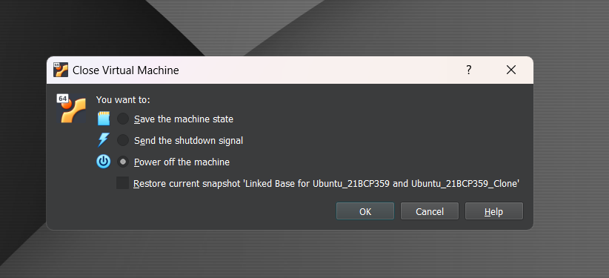

* 1. Soft Power Off

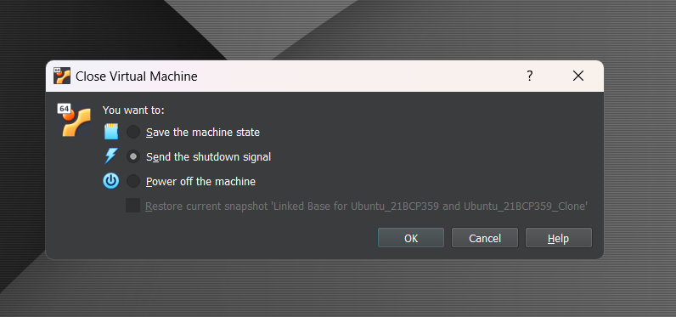

* 1. Configure Virtual Machine to Run in the Background



* In Start menu of VM click Headless Start

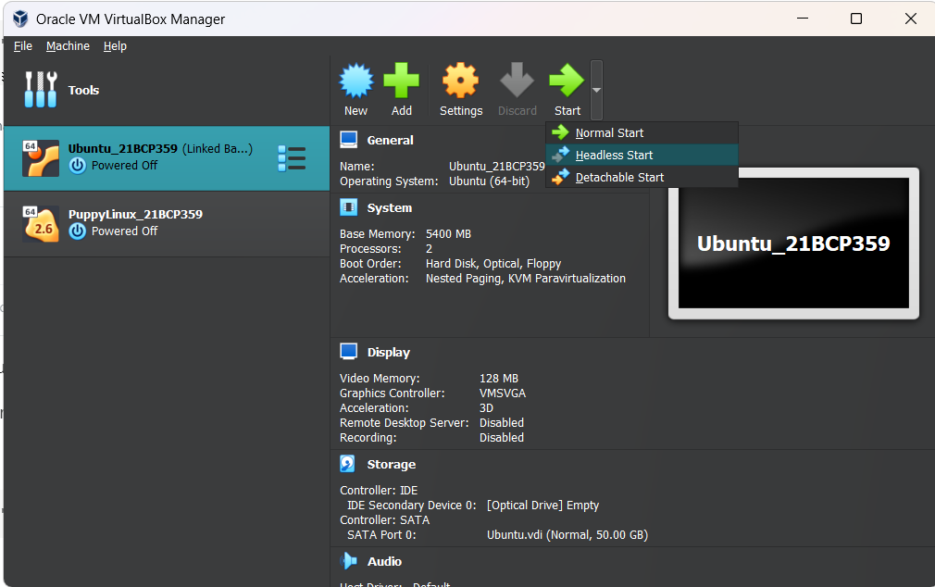

* 1. Pause and Un-pause a Virtual Machine



Right click on VM and click Pause to Pause

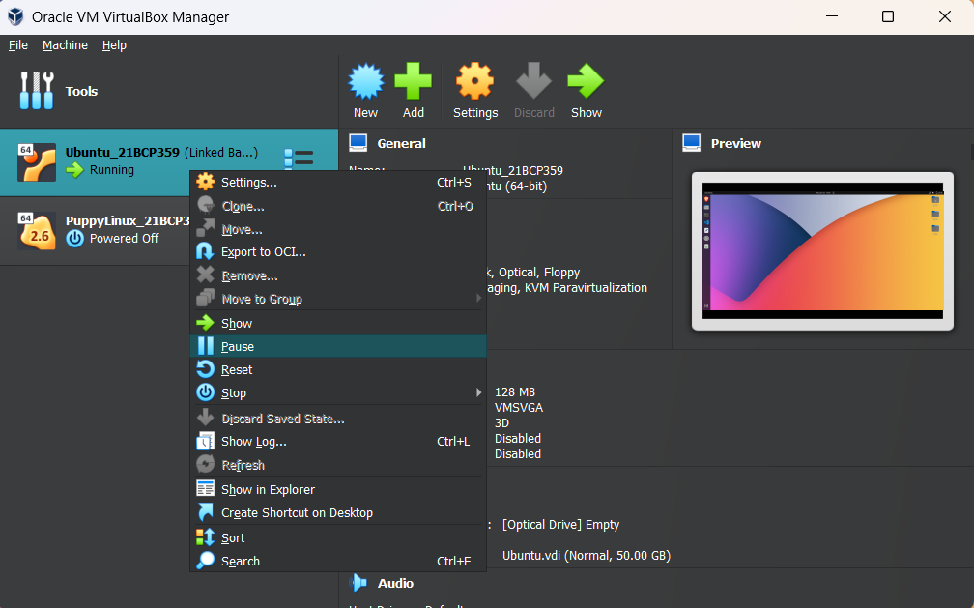

Again click Pause to Resume

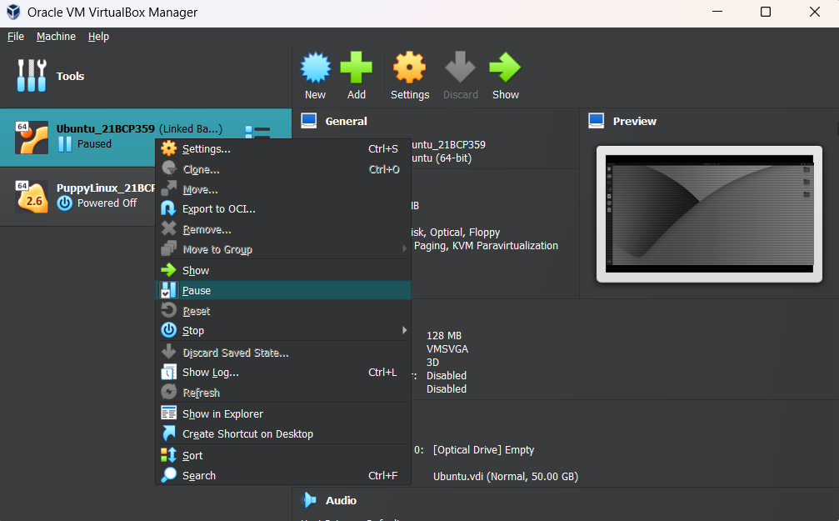

* 1. Pause all Virtual Machine without interacting Virtual Box

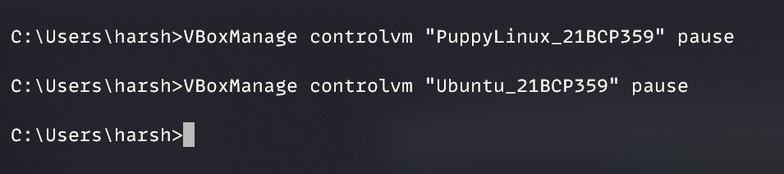

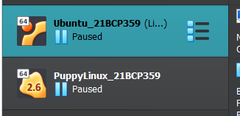

* 1. **Suspend and Resume Virtual Machines**

In power menu of Guest OS click Suspend

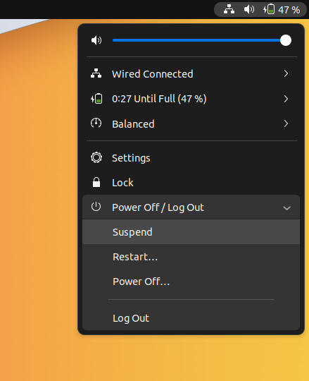

1. **Delete a Virtual Machine from the disk**

Right click on VM and select Delete. Then click Delete all files

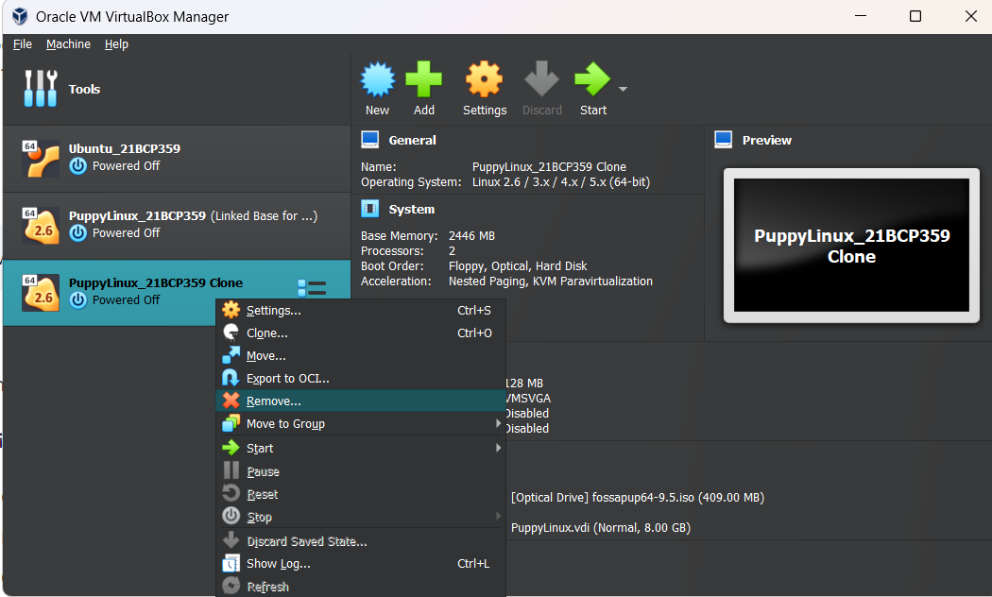 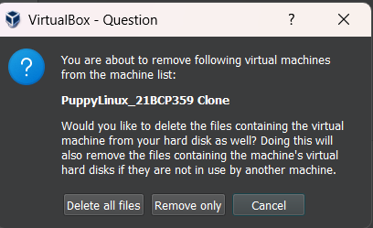

1. **To take snapshot of Virtual Machines**

Click on Tools icon on VM and select Snapshots. Give a name and click OK

